**INTERFACING OF RELAY AND LED WITH 8051 USING PROTEUS**

**AIM:**

To write an assembly language program to interface relay and LED with 8051 using Proteus.

**SOFTWARE REQUIRED:**

* Proteus 8 software.

**PROGRAM:**

ORG 0000H ; Start of program

; Initialize Port 1 as output port for relay control

MOV P1, #00H ; Clear Port 1 (all pins low initially)

MAIN_LOOP:

SETB P1.0 ; Set P1.0 HIGH (Relay ON, LED ON)

ACALL DELAY ; Call delay to keep the LED ON for some time

CLR P1.0 ; Clear P1.0 (Relay OFF, LED OFF)

ACALL DELAY ; Call delay to keep the LED OFF for some time

SJMP MAIN_LOOP; Repeat the process

; Delay subroutine for blinking speed

DELAY:

MOV R1, #255 ; Outer loop

DELAY1:

MOV R2, #255 ; Inner loop

DELAY2:

DJNZ R2, DELAY2 ; Decrement inner loop

DJNZ R1, DELAY1 ; Decrement outer loop

RET ; Return to main loop

END ; End of program

**CIRCUIT DIAGRAM:**

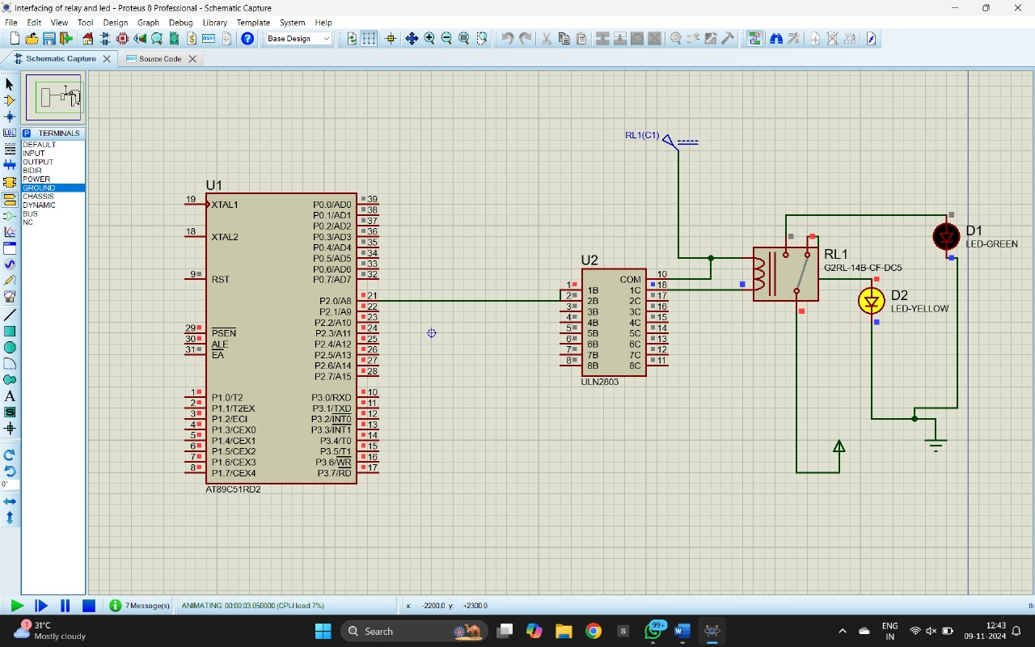

**OUTPUT:**

* The LED connected through the relay will blink with a controlled ON and OFF duration.
* The relay acts as a switch controlled by the 8051 microcontroller, turning the LED ON when P1.0 is HIGH and OFF when P1.0 is LOW.
* The blinking rate of the LED can be adjusted by changing the delay subroutine.

**RESULT:**

Thus, the program has been successfully verified and executed.